Business and Marketing Plan
Flutter Clean Architecture VS Code Extension (Extended)
1. Executive Summary
The Flutter Clean Architecture VS Code Extension (Extended) is an open-source developer productivity tool designed to automate feature scaffolding for Flutter applications using Clean Architecture. The extension supports multiple state management patterns BLoC, Riverpod, and Provider addressing a common pain point in Flutter development: repetitive boilerplate creation and architectural inconsistency.
This business and marketing plan focuses on community-driven growth, organic adoption, and developer trust-building, rather than direct monetization. Marketing efforts emphasize visibility, education, and engagement within Flutter and software engineering communities using low-cost, high-impact platforms: Telegram, Reddit, Facebook, LinkedIn, and X.
2. Product Value Proposition
Core Value
- Saves development time by automating feature setup.
- Enforces Clean Architecture best practices.
- Supports multiple state management patterns in one tool.
- Integrates seamlessly into VS Code workflows.
Target Problems Solved
- Manual and repetitive folder/file creation.
- Inconsistent architectural implementations across teams.
- Steep learning curve for Clean Architecture and state management.
- Lack of tooling flexibility when switching state management approaches.

3. Target Market and Audience
Primary Target Audience
- Flutter developers (junior to mid-level).
- Computer science and software engineering students.
- Developers learning Clean Architecture.
- Early-career professionals building portfolio projects.
Secondary Target Audience
- Tech leads mentoring junior developers.
- Open-source contributors interested in tooling.
- Educators teaching Flutter architecture.
Geographic Scope
- Global, with emphasis on regions active in Flutter communities (Asia, Europe, Africa, North America).
4. Marketing Objectives
- Increase awareness of the extension within Flutter communities.
- Drive traffic to the GitHub repository.
- Encourage downloads, usage, and GitHub stars.
- Collect user feedback for iterative improvement.
- Attract first-time open-source contributors.
5. Marketing Strategy Overview
The marketing strategy follows a community-first, content-led approach:
- No paid advertising.
- Focus on authenticity, problem-solving, and education.
- Leverage developer communities where Flutter developers already interact.
- Position the tool as both practical and educational.
6. Platform-Specific Marketing Plans
6.1 Telegram Marketing Plan
Purpose
- Direct engagement with Flutter-focused communities.
- Rapid feedback and informal discussions.
Target Channels
- Flutter developer groups.
- Campus and student programming groups.
- Mobile app development communities.
Content Strategy
- Short introduction posts explaining the problem and solution.
- Feature highlights (multi-pattern support).
- GitHub repository and release announcements.
- Screenshots or short demos.
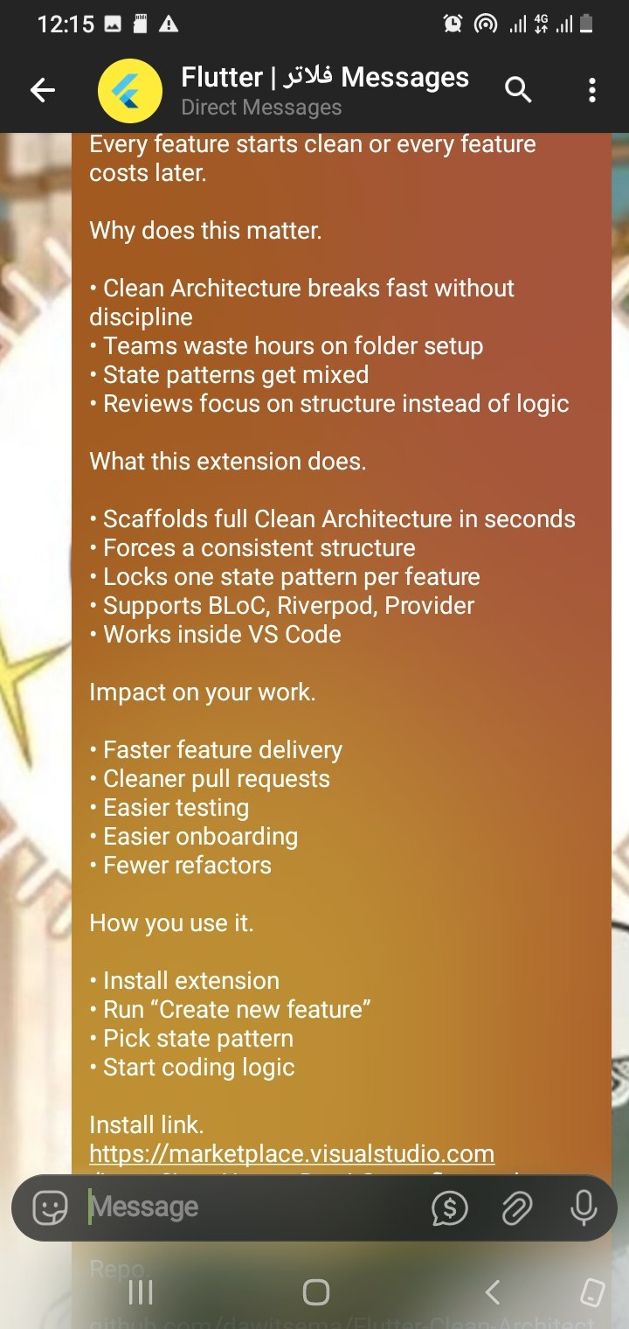
Posting Frequency
- 1 posts per relevant group.
- Follow-up only when meaningful updates are released.
Key Message
“We all know Clean Architecture is the "gold standard" for building scalable, testable Flutter apps. But let’s be real manually creating Data, Domain, and Presentation layers for every single feature is a productivity killer.
I’m excited to share Flutter Clean Architecture Extended a VS Code extension designed to handle the boilerplate so you can focus on the logic

Success Metrics
- Click-throughs to GitHub.
- Questions or replies in groups.
- Direct feedback messages.
6.2 Reddit Marketing Plan
Purpose
- Reach experienced Flutter developers.
- Encourage technical discussion and validation.
Target Subreddits
- r/FlutterDev
- r/dartlang
- r/opensource
Content Strategy
- Problem-solution style posts.
- Transparent explanation of what the extension does.
- Emphasis on open-source and learning value.
- Avoid promotional language; focus on contribution and usefulness.
Example Positioning
“ We all know Clean Architecture is the "gold standard" for building scalable, testable Flutter apps. But let’s be real manually creating Data, Domain, and Presentation layers for every single feature is a productivity killer.
I’m excited to share Flutter Clean Architecture Extended a VS Code extension designed to handle the boilerplate so you can focus on the logic.”
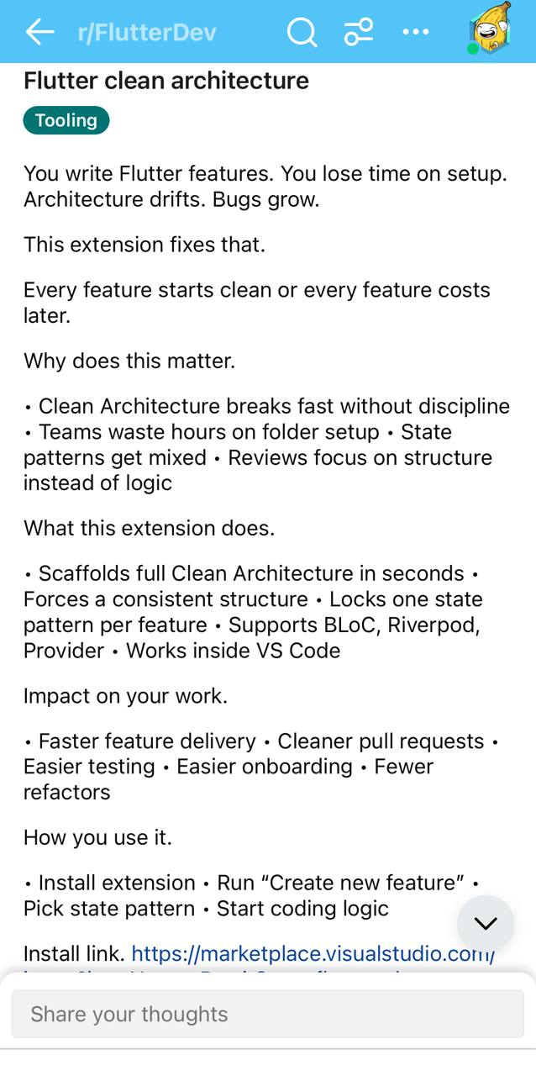
Posting Frequency
- Initial launch post.
- Follow-up posts only for major updates (e.g., new version).
Success Metrics
- Upvotes and comments.
- Repository visits from Reddit.
- Feature suggestions and issues opened.

6.3 Facebook Marketing Plan
Purpose
- Reach students, beginners, and mobile dev communities.
- Promote adoption among learning-focused groups.
Target Groups
- Flutter & Dart developer groups.
- Mobile app development groups.
- University programming communities.
Content Strategy
- Beginner-friendly explanations.
- Visual content (folder structure screenshots).
- Emphasis on time-saving and learning benefits.
- Clear instructions on how to install and use.
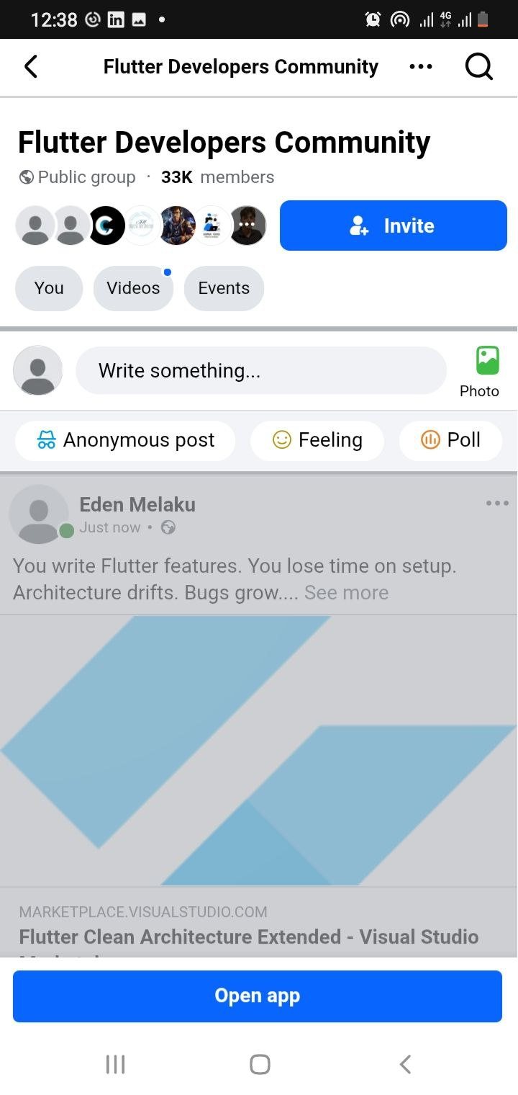
Posting Frequency
- 1 post per group during launch.
- Occasional updates for major improvements.
Key Message
“A free VS Code extension that helps Flutter developers follow Clean Architecture without manual setup.”

Success Metrics
- Post engagement (likes, comments).
- Repository traffic.
- Messages requesting help or clarification.
6.4 LinkedIn Marketing Plan
Purpose
- Professional credibility and academic visibility.
- Reach educators, mentors, and early-career professionals.
Target Audience
- Software engineers.
- Computer science students.
- Technical recruiters and mentors.
Content Strategy
- Project announcement posts.
- Explanation of technical challenges solved.
- Emphasis on open-source contribution and learning outcomes.
- Position the project as part of professional growth.
Tone
- Formal and reflective.
- Focus on engineering discipline and tooling quality.
Posting Frequency
- Initial announcement.
- Optional follow-up discussing lessons learned or future roadmap.
Success Metrics
- Profile views.
- Post engagement.
- Professional connections and feedback.

6.5 X (Twitter) Marketing Plan
Purpose
- Short-form visibility.
- Engage with Flutter and open-source influencers.
Target Audience
- Flutter developers.
- Tooling and open-source enthusiasts.
Content Strategy
- Short technical announcements.
- Feature highlights.
- Version release notes.
- Use of relevant hashtags.
Example Hashtags
- #Flutter
- #CleanArchitecture
- #OpenSource
- #VSCode
- #Riverpod
- #BLoC
Posting Frequency
- 2–3 tweets during launch week.
- Tweets for major releases only.
Success Metrics
- Impressions and retweets.
- Profile visits.
- Repository clicks.
7. Feedback and Community Engagement
Feedback Channels
- GitHub Issues.
- GitHub Discussions (planned).
- Comments and replies on social platforms.
Engagement Strategy
- Respond to feedback professionally and promptly.
- Label beginner-friendly issues.
- Acknowledge contributors publicly.
- Incorporate community suggestions into roadmap planning.
8. Roadmap Alignment with Marketing
Marketing activities are aligned with development milestones:
- New state management patterns → announcement posts.
- Major refactors or improvements → technical write-ups.
- Documentation improvements → beginner-focused outreach.
This ensures that promotion always corresponds to real value additions.
9. Risk Analysis and Mitigation
Risks
- Low visibility due to no paid marketing.
- Content perceived as promotional spam.
- Limited time for community engagement.
Mitigation Strategies
- Focus on educational and problem-solving messaging.
- Limit posting frequency.
- Engage authentically in discussions rather than broadcasting.
10. Conclusion
This marketing plan leverages organic, community-driven platforms to promote the Flutter Clean Architecture VS Code Extension (Extended). By focusing on developer pain points, open-source values, and educational impact, the project positions itself as a credible, useful, and sustainable tool within the Flutter ecosystem.
The use of Telegram, Reddit, Facebook, LinkedIn, and X enables broad yet targeted reach, ensuring the project gains visibility while fostering meaningful engagement and long-term adoption rather than short-term promotion.

